Speedometer Drive Position

Internal space limitations require the 32-38 position to be rotated 180 degrees (half turn) from normal. This will move the plastic drive gear away from internal parts that will destroy the plastic gear. Other tooth count positions are used as normal.

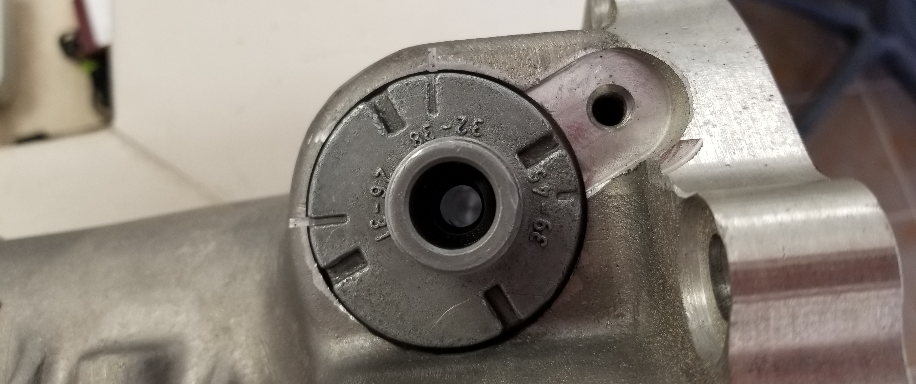
(Pictured below is the stock orientation for the 32-38 tooth speedometer drive gear housing, this position is INCORRECT for the A855)

(Pictured below is the CORRECT orientation of the 32-38 tooth speedometer drive gear housing for the A855 transmission)


